Azure Cloud Assignment

* Create a virtual network with 2 subnets. Each subnet should have 16 Ips only.

1. Creating a virtual network.

1. Created 2 subnets with 16 Ips. 5 out of 16 Ips are azure reserved addresses.

* Inside one of the subnets, create a VM and deploy an application code inside it and it should leverage the database on the cloud (any existing application created by you before)

1. Created a VM in one of the subnets.

1. Created an azure SQL database for our application on the azure portal.

1. Configured the database connectivity file in our application to connect it to the azure SQL database.

1. Connected database to our application and table is added for our application.

* Deploy the same application to Azure App Service. It should also leverage the database on the cloud.

Deployed our application to azure app service using web app resource in azure

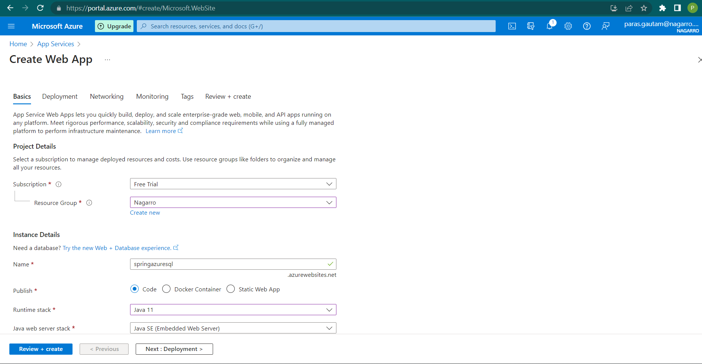

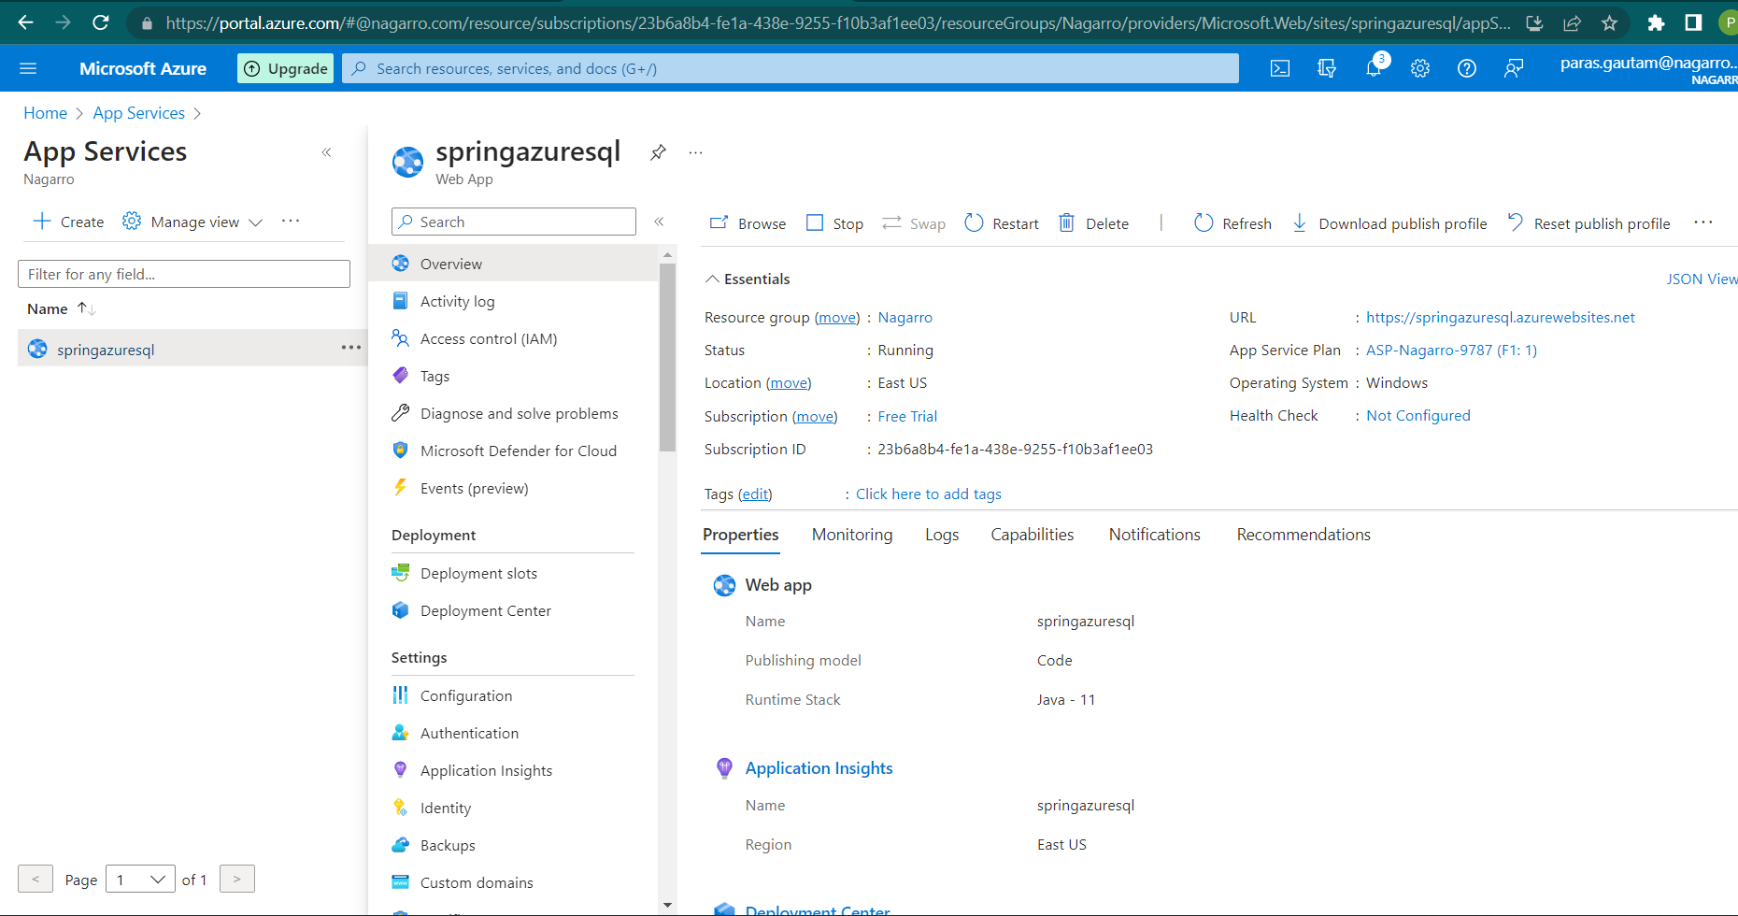

* Create the AKS cluster (2 nodes, smallest size VM) and deploy any two services on it. Services should be accessible from the internet.

1. Created Kubernetes cluster on azure portal with 2 nodes and smallest size VM.

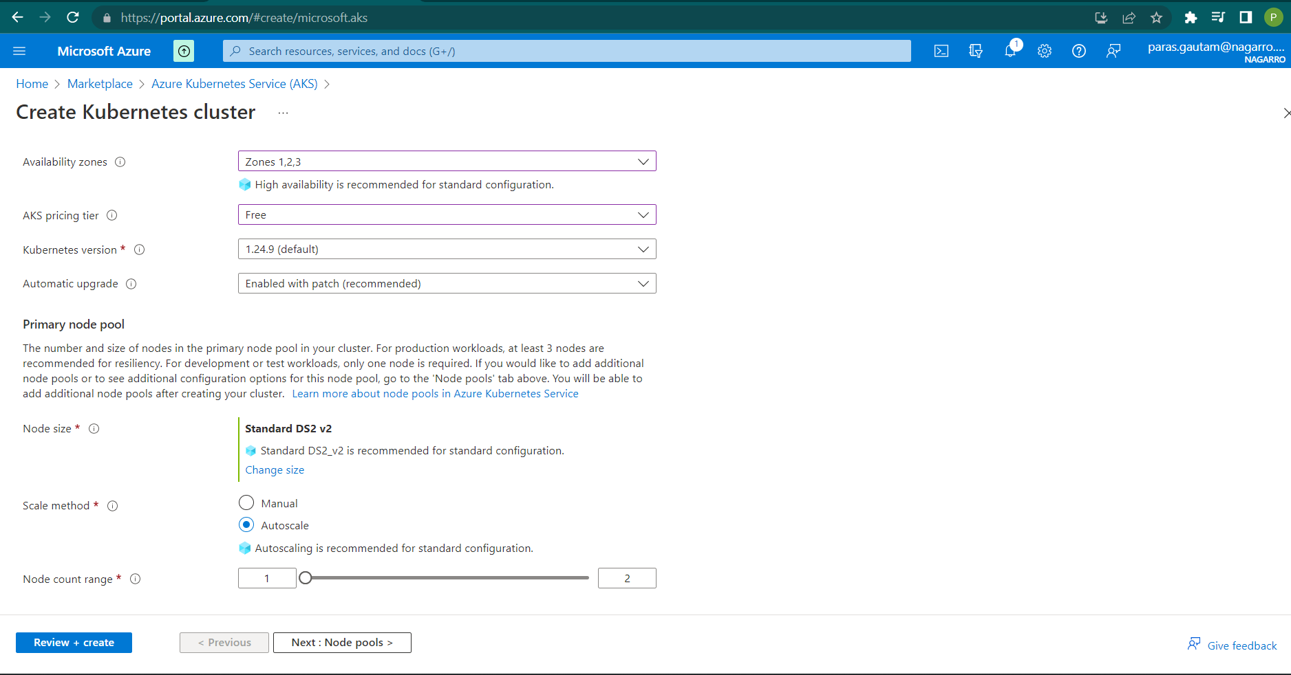

1. Created a YAML file to deploy our services on the Kubernetes cluster on the azure cloud VS code.

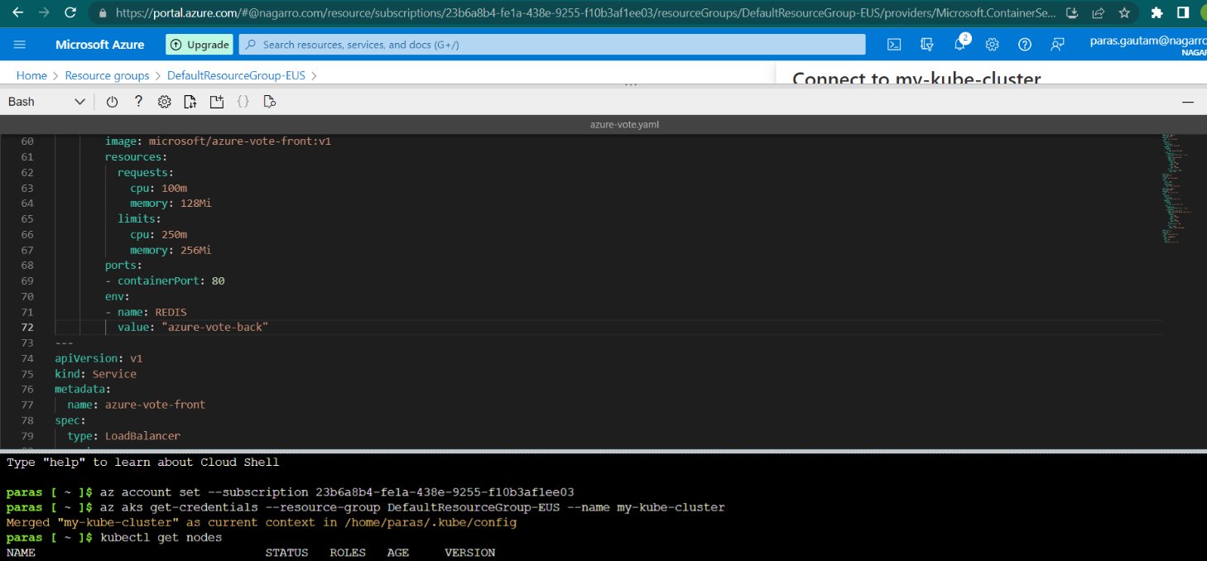

1. Executed our services on the Kubernetes cluster. One service is for the backend and one service is for the frontend.

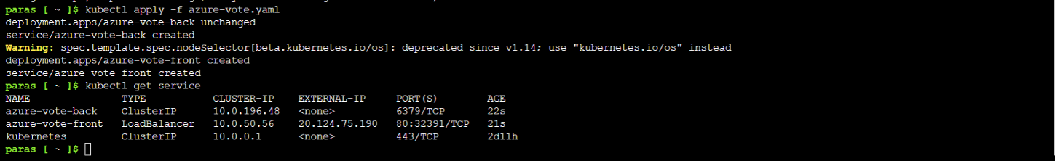

* Create an Azure function that should trigger as soon as you upload a file in the blob storage. Function should be able to print the name of the file uploaded in the function.

1. Creating a storage account and function app to implement blob storage trigger and azure function

